Implementing ‘Leading to Apprenticeship Model’ with the Private Sector – Opportunities and Challenges
What is Leading to Apprenticeship Model?
Given the time constraint to implement a full 24-month long Apprenticeship model, the Leading to Apprenticeship Model (LAM) of a shorter 6 months (900 hours) duration was innovated by SAMRIDHHI Project. Majority of the learning is practical, where the trainees learn under the guidance of a craftsperson, a skilled employee working in an industry and assigned to train the apprentices in a particular trade. The first month is the classroom based practical training which is aimed at clarifying concepts. Practical learning under the guidance of the craftsperson begins in the second month of the course. Upon completion of the training course, the final assessment of the trainees’ skills level is carried out in-house first. For training courses having the Occupational Skills Standards (OSS), the trainees can appear for the Level 1 skills test carried out by National Skills Testing Board (NSTB). The agency assigned for the implementation of the apprenticeship programme (either the Training & Employment Service Providers or the technical school of CTEVT or the Federation of Nepalese Chambers of Commerce and Industry (FNCCI) Province office) takes the responsibility to place apprentices at jobs in industries where they were trained in (or in other industries but in the same trade in which they were trained in). To incentivize the trainees to enrol and complete the training, they are given a monthly stipend of NPR. 4950 by the industries. The Project is currently implementing LAM 1 and LAM 2 in 16 districts of Province 1, Madhesh Province and Bagmati Province.

About LAM 1: In LAM 1, the Project Management Office (PMO) of SAMRIDHHI’s sub-component 1.3 (Decent Jobs) enters into an agreement with the training and employment service providers (T&Es) or the technical schools of CTEVT who are responsible for managing quality trainings in the classrooms as well as in the industries, preparing and ensuring that the trainees appear for government’s skills test and placing them into decent jobs. In LAM 2, the Project enters into an agreement with the FNCCI of the respective provinces. The FNCCI is responsible for the overall management and implementation of training, skills test and the transition of the graduates to work through its member industries. LAM 2 was implemented in Province 1 and has the scope for replication in other provinces as well.

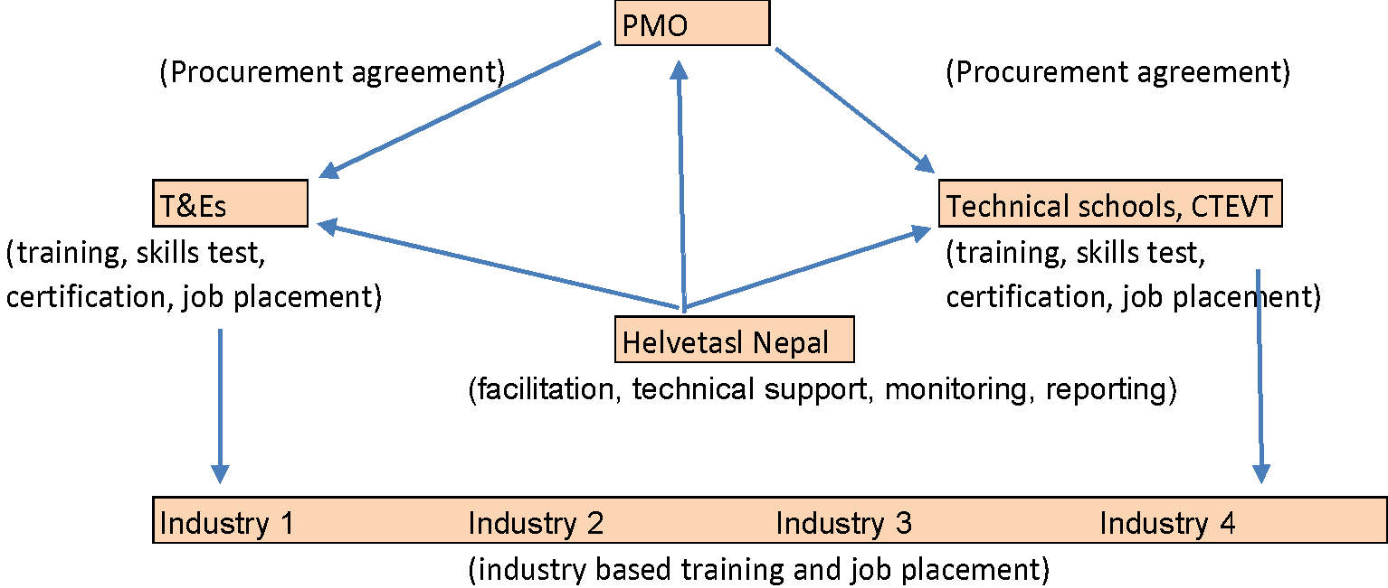
Figure 1: LAM 1

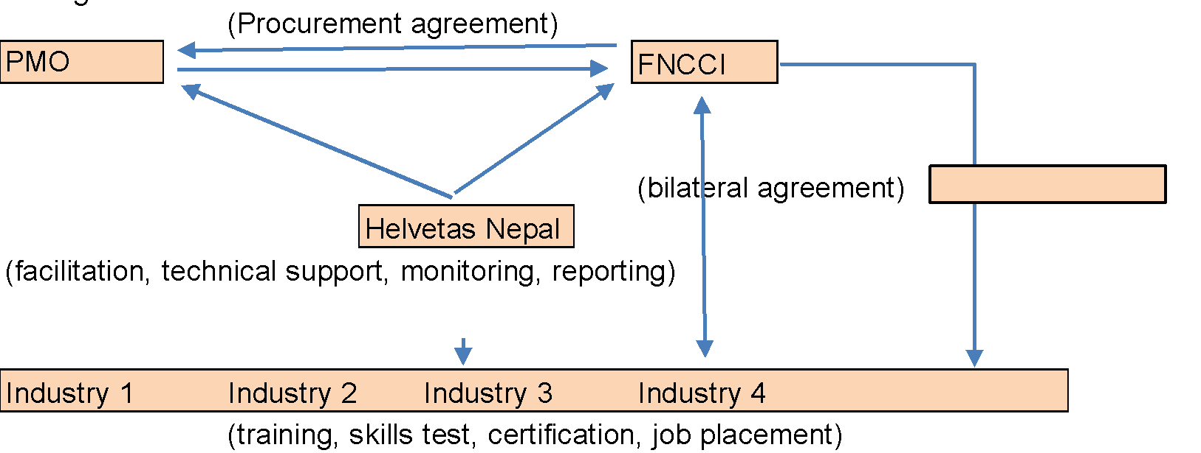
Figure 2: LAM 2
The model applies outcome-based payment and differential pricing model to incentivize the implementing party (T&Es or/and the technical schools of CTEVT in case of LAM 1 and FNCCI in case of LAM 2) to support as many apprentices for job placement meeting the minimum salary threshold and to include as many from the Project’s targeted beneficiaries.
Programme status
The target set for training in Apprenticeship initially was 6000 youths, which was revised. The delayed commencement of the sub-component (Decent Jobs) in 2018/19 gave the Project only about three years to attain the target. A need to review and set a realistic target was felt given the situation - regular apprenticeship model being a 2-years long course, the interruptions to training and life as a whole due to the pandemic from March 2020 onwards, and the negative impact it had on industries and employment. The target was thus revised to 4500 and then owing to the FNCCI having to channel its committed fund to fighting the more pressing needs triggered by the pandemic, the target was further reduced to 2800.
Of the 2800 trainees, 2500 were to be reached through LAM 1 and 300 through LAM 2. The first procurement led to the enrolment of 1000 apprentices through LAM 1 and 300 apprentices through LAM 2. Their status of training completion and employment is presented below.
Fiscal Year | Training Type | Trained youth |  |  | Employed Graduates
 |  | Total | Women (%) | DAG (%) | Total | Women | DAG | Income/month (NPR)
2020/21 | LAM -2 | 284 | 64% | 97% | 86% | 64% | 97% | 16700
2020/21 | LAM -1 | 841 | 64% | 91% | All 41 events completed, 3-month employment & income verification has started

The Project is in the process of negotiating the procurement of service from the T&Es to implement LAM 1 to 1500 youth. Due to the encouraging results obtained from LAM 2, the Project has decided to implement another round of LAM 2 (this will be in addition to the target that had initially been set for LAM 2).
A total of 14 curricula of CTEVT were revised by the Project to align with the LAM model. The T&Es (under LAM 1) partnered with 119 industries, whereas the FNCCI of Province -1 (under LAM 2) partnered with 8 industries in total.
The general feedback that the private sector (the Training & Employment Service providers, industries and the FNCCI) had about this model of apprenticeship was that the training offered a good placement prospect to the trainees; because the trainees had the opportunity to earn as they were learning, their incentive to complete the training was high; from the employers side, the training was a good opportunity to develop human resource with the right skill and in the right number. Their concern however was with the recognition and certification of the trainees’ skills through the NSTB and to bring together the apprentices at least once every fortnight for learning and sharing in a classroom setting from the current once every 2 months.
“This kind of training (of Machine Operator, conducted under Leading to Apprenticeship Model-2) has been very much beneficial for us. It provided us with the opportunity to develop human resources on our own as per our requirement. With the support of the FNCCI of Province 1, under the SAMRIDDHI Project, we developed 59 persons as Finishing Machine Operators by imparting training to them for six months. Out of the total trained, 57 are working here with us. Generally, we don’t get skilled persons as workers, but this training helped us to get trained human resources. We are in need of additional 50 trained persons.”
Ganesh Nepal, General Manager, Pulse Fashion Solution Pvt. Ltd., Biratnagar, Morang
.
“Leading to Apprenticeship Model (LAM) was a totally new model for us. Initially, we signed an agreement with SAMRIDDHI to impart training to 10,040 individuals. Nevertheless, due to the pandemic we commenced the training in the later part of 2020 only. Keeping in mind the effect of the pandemic on the industries and employment, the target was revised. We succeeded in imparting training to 284 persons, 64% of whom were women. Now 86% of them are working in the collaborating member industries making an average monthly income of NPR. 16,700. This model has really been fruitful as it benefits both unemployed youths by ensuring their employment and the member industries by helping them to produce the required human resource. We faced some challenges that included lack of updated curricula and the lack of provision for skills tests by the NSTB. We did a lot of learning too - as this kind of shortened apprenticeship model is very much suitable for fulfilling the labour/human resource demand of our member industries within a short span of time, we are looking forward to getting opportunities to implement similar projects in near future in a more effective way.”
Radha Raman Bhandari (Sam), Executive Director, FNCCI, Province -1, Biratnagar

“We imparted trainings of cook and waiter to 60 youths in collaboration with SAMRIDDHI using the LAM 1 model. We have good experience with imparting skills training and can say with certainty that employment is higher in the apprenticeship model. Though the six-month income verification is yet to be conducted, I can confidently declare that more than 80% of the trainees will be in gainful employment. As this model is implemented in fiscal year 2020-2021 for the first time, it has ample room for improvement. Firstly, it needs to have suitable curricula and the linkage with NSTB for skill test. It also needs to arrange to have mechanisms of bringing the apprentices together at least once every fortnight during the industry-based training period. Doing this will help to track the status of the apprentices’ learning.”
Karuna Nidhi Gyawali, Managing Director, Brilliant Manpower Training Center Pvt. Ltd.

Opportunities and Challenges
Skills test: LAM 1 and LAM 2 were the innovations of the Project. They use the existing CTEVT curricula adjusted for 900 hours by the Project. Because the CTEVT as such does have 900 hours courses, there are also no OSS for these, hence no existing provisions for skills test by the NSTB. Since it is the certificate that is evidence of one’s skills and knowledge, there is a request for recognition of the skills by the trainees, the industries and the T&Es. One alternative under exploration is the possibility of skills recognition/certification at the local government level in collaboration with the FNCCI. A few participants of Machine Operator under LAM-2 have appeared in the skills tests conducted under Parallel Learning Recognition (PRL) in facilitation with the Nepal Vocational Qualification System (NVQS).
T&Es as implementing partners: With their experience and knowledge of the vocational educational sector, the T&Es have the needed infrastructure, resources, trainers, understand the importance of gender and social inclusion and the process of training implementation, skills test, and have contacts with industries for placement of apprentices. These make them a good training implementation partner of the Project. However, most are too dependent on grant support and are quite hesitant to deliver under cost sharing basis such as the Outcome-based Payment. Their reach to big industries employing a large number of human resources is limited and hence they collaborate with a large number of small industries, leading to a thin spread of resources.
Craftspersons as trainers in industry-based training: The Project as well as the industries must put effort into developing these craftspersons as effective trainers with skills in training delivery and training management. These individuals with five years or more experience in the respective trade have good practical skills and knowledge but sometimes have difficulties expressing/delivering them in an effective manner in a classroom environment.
FNCCIs as implementing partner: The Provincial FNCCIs being the umbrella organizations of the industries present themselves as a very good platform to implement the LAM to meet the human resource needs in skilled and semi-skilled labour of the industries and the placement of the youth for training and employment. They are accountable towards their member organizations as well as the employees working there. However, they lack previous experience with implementing training and human resources and warrants support from the Project for the institutionalization of the LAM.
LAM found beneficial by both trainees and industries: Both the industries and the trainees appeared to favour the short six months course with intensive practical learning that readied them for employment and income, a win-win situation for both. The monthly stipend that the industries paid to the trainees in industry-based training that starts the second month of the training further incentivized them to join and complete the training for assured employment in the same industry where trained. The industries benefited from the human resources with the actual skills needed by them.

Average income per month for within 6 months of income verification
1) Tailoring 2) Aluminium Fabrication 3) Carpet Weaver 4) Motorcycle Service Mechanics 5) Bricklayer Mason 6) Building Electrician 7) Cashier cum Receptionist 8) Early Childhood Montessori Facilitator 9) Indian Cook 10) Assistant Waiter 11) Air Conditioner and Fridge Mechanics 12) Commis III 13) Furniture Maker and 14) Junior Plumber

