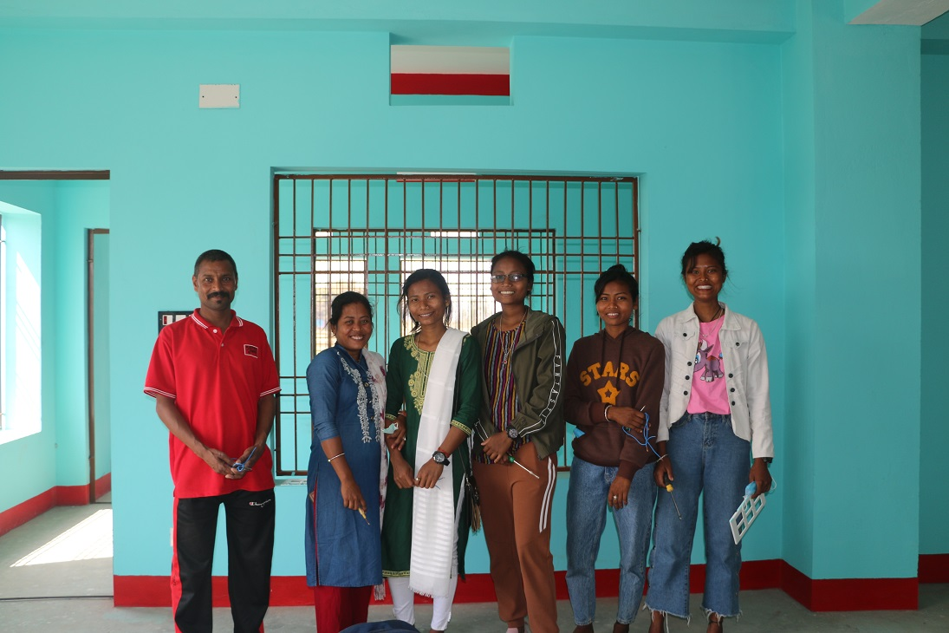
A Tale of Five Women Electricians of Lahan
The five women electricians with their contractor in a working site

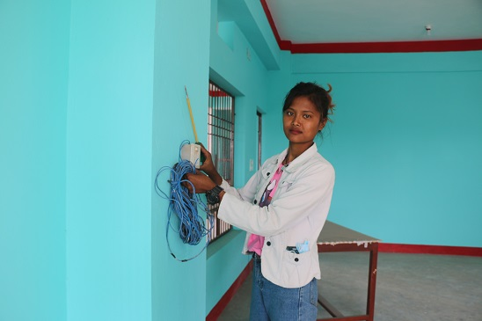
In January 2020, an event of building electrician training (level -1 of 390 hours) with 20 participants was organized in Lahan under SAMRIDDHI Project in collaboration with a training and employment service provider called Creative Skills Private Limited. Among all 20 participants of the training, six participants were women, and five women successfully completed the training. When we reached the premises of a newly built polytechnical college, located at Lahan to meet the five women graduates, the view of them working as electricians grabbed our attention. They were working under the contract of Ram Udgar Thakur who was their instructor during the training period. All of the five building electrician women namely, Asha Chaudhary, Raina Chaudhary, Dipmala Chaudhary, Kamali Chaudhary and Nirmala Chaudhary belong to Tharu, an indigenous community of terai. While being asked about their job as an electrician, Asha enthusiastically says, “We have started to work just before the Dashain festival in 2021. All of us go together to search for work. The brother-in-law of Rabina is an electrician. Sometimes we team up with him to work. Mostly, we are provided the work by our trainer who is a contractor too. Now we can easily perform tasks like installation of conduits and pipes, installation of circuit breakers and other electrical hardware, connection of electrical systems to power lines to provide electricity to the building, inspection of electrical systems to determine whether repairs are needed, replacement of conduit and wiring and replacement of circuit breakers.” With a mild giggle she continued her statements further, “Prior to receiving the training, we were only acquainted with the switch and holder”. Asha Chaudhary is a 24-year-old resident of Lahan municipality. She has passed the School Level Certificate (SLC). Due to her family’s poor economic condition, she could not pursue her study further after SLC. Their only property was their land which they sold for the treatment of her father who is a cancer patient. Her brother works as a mechanic repairer. Sharing about her income as a building electrician she says, “We normally remain engaged in our work for 25 days in a month and our income ranges from NRs. 15000 to NRs. 20,000 per month. I give my income to my mother. She uses it to manage our household expenses as my brother’s earning is mostly spent in my father’s treatment.”
Asha Chaudhary working as an electrician

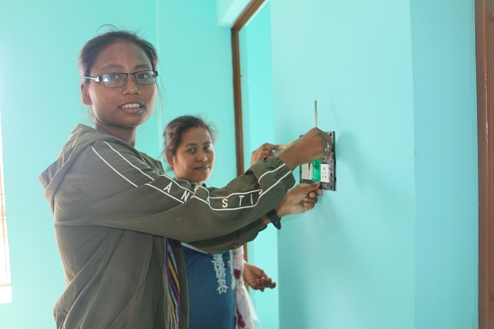
Regarding her work as an electrician Rabina excitedly shares, “We want to lead big contracts as building electricians in coming years. For that we have to gain confidence over our work. I am sure that our constant engagement will make our aspiration manifest in the near future. These days, we work together in an exclusive group of women to apply our theoretical knowledge in practical actions.” While being asked of her motivation behind participating in the training of building electrician, Rabina says, “It was our friend Kamali who motivated us to join the training as my own brother-in-law is also an electrician and his earning is good, I also find her proposal sensible and started to motivate my friends to join the training. Thus, we formed a group of six women and applied for the training. Fortunately, we got selected and succeeded in the training. Only one woman of our group dropped it due to her personal issue.” Rabina Chaudhary is a 24-year-old resident of Lahan -9. There are 7 members in her family. As her family does not have their own farm to produce food, they work as agricultural laborers in the farms of their neighbors. She completed her plus two (grade 12) level study amongst her financial hardships as she had to earn herself as an agricultural laborer to manage her expenses. She narrates the beginning days of her training, “I got ready to partake in the training, but I had a fear that I would be killed by the electrical shocks. But within a few days of the training’s startup, the fear vanished away. As each day of the training gave us opportunities to learn new things through both theoretical and practical session, we participated in the training with boundless zeal and enthusiasm.”
Rabina Chaudhary working as an electrician

Dipmala Chaudhary shares her joy of being able to earn in her own words, “Money is required to do everything, isn’t it? Now I earn NRs. 15,000 – 20,000 per month. This amount is very much helpful in managing household expenses of my family. With my first income, I bought new clothes for all of my family members for them to wear in Dashain festival. I still remember the joy which was reflected on their faces upon the reception of such gifts from me”. Dipmala Chaudhary is a 22-year-old resident of Lahan ward number 1. In her family, there are 6 members including parents, a grandfather and her two siblings. Her family owns a small portion of land which hardly yields food for six -seven months of a year. Her earning as an electrician is helping her family in household expenses.
Figure 1Rabina Chaudhary working as an electrician
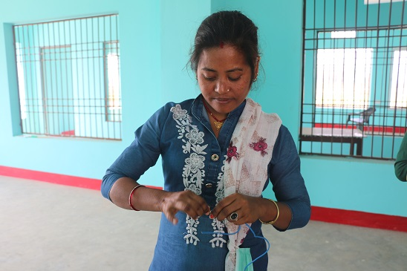
Kamali Chaudhary says, “The very women of our neighborhood who used to laugh at us for joining the building electrician’s training now regret for their action and request us to let them know whenever such trainings get announced in our locality.” Kamali Chaudhary is a resident of Dhangadimai -1. Her husband is in foreign employment in Qatar. When she came to know of the announcement of building electrician training, she consulted with her husband about it. Her husband encouraged her to join the training. As the training was conducted in Lahan which is her parental town. She decided to stay at her parental home during the training period. She also inspired her childhood friends to join the training. Thus, succeeded in forming a group of six women to attend the training. Her eyes glittered when she recalled the day when she received her first income, “When I gave my first income to my mother-in-law, her eyes got wet with joy. That sight was so precious for me that I still remember it vividly. I called my husband to share my happiness and he also cheered. My husband is in the foreign land with a 10 year long working visa. He has spent only 2.5 years there. I wish he could be back sooner, and we would get to live together. I hope that when my earning will start increasing, he will not have to stay away from home for earning.”
Kamali Chaudhary working as an electrician

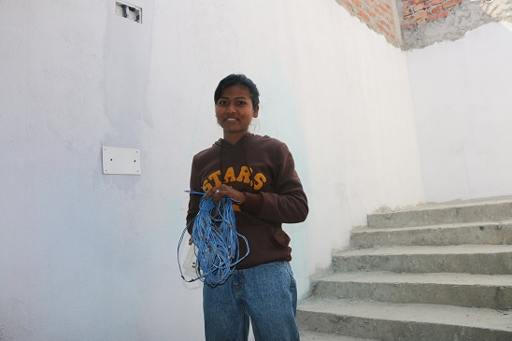
Niramala Chaudhary, 20 years old, is also a resident of Lahan. She has studied up to grade 10 and she could not continue her study further. In her family, there are 7 members. Her father works in the ticket booking counter of a local bus-park and her brother is a plumber. As her family does not have land to produce crops, the income of her brother and father was not enough to fulfill all needs of the family. She expresses her joy of being able to earn herself, “I really feel good about being able to earn myself. Now I have started to save my money by opening a bank account. I plan to resume my studies with the money that I have been saving”.

When we were ready to part after the conclusion of the conversation with them, they thanked SAMRIDDHI for providing them the opportunity to learn the skills of building electricians and be self-reliant.

